IST 652 - Scripting for Data Analysis
Airbnb Price Analysis and Prediction - U.S. Markets

Group Delta: Brian Lee – Robin Nightingale
Hector Pena – Natajah Roberts

Table of Contents:
Introduction ................................................................................................................ 3
Data Exploration ........................................................................................................ 4
Methodology ................................................................................................................ 8
Results........................................................................................................................... 9
Conclusions ................................................................................................................. 11
Conclusion Remarks .................................................................................................. 12
References .................................................................................................................... 14

Introduction:
Airbnb price prediction across U.S. markets presents a multifaceted challenge that significantly impacts hosts, investors, and travelers. Accurate pricing predictions can optimize revenue strategies, enhance market understanding, and support investment decisions in the rapidly evolving short-term rental sector. Current approaches often rely solely on platform-specific data and seasonal trends, which may not fully capture the complex interplay between economic conditions and local market dynamics.
This program analyzes merged Airbnb and CPI data to answer four key research questions: (1) Price forecasting, for future Airbnb prices across key markets. (2) summary analysis of pricing patterns across different property characteristics with economic indicators, (3) categorical analysis of listings by temporal periods and geographic regions, and (4) comparative analysis between different market segments and time periods.
Our project focuses on predicting Airbnb pricing trends across major U.S. cities by incorporating external economic factors such as the Consumer Price Index (CPI) alongside traditional listing characteristics. The analysis focuses on Airbnb listings data from 2020 and 2023 merged with Federal Reserve CPI data to understand pricing dynamics in the short-term rental market during a period of significant economic change.
This innovative approach utilizes advanced machine learning algorithms and time series analysis to generate actionable insights into market dynamics. By integrating macroeconomic indicators with property-specific features, we aim to provide stakeholders with comprehensive tools for pricing optimization and market forecasting in the dynamic short-term rental landscape.
Stakeholder's Needs:
For Airbnb market participants, understanding pricing dynamics and market forecasting is crucial for strategic decision-making in the rapidly evolving short-term rental landscape. The pricing analysis and prediction models provide valuable insights for hosts, property investors, platform managers, and market analysts. Here's how:
- Revenue Optimization for Hosts: Host should prioritize location precision and room type optimization since these factors drive 43% of pricing power, while focusing on recent guest engagement rather than accumulating total reviews.
- Investment Strategy for Property Investors: Investors can choose between volume markets (California with 51,273 properties) or premium markets (Texas at $322 rates), but should rely on market fundamentals rather than predictive models given the 37.6% accuracy limitation.
- Market Entry and Expansion Planning: Market Entrants benefit from understanding that the top 10 states control 187,786 listings, revealing both saturated and opportunity markets where volume doesn't always equal pricing power.
- Platform Management and Policy Development: Platform Managers need dynamic pricing tools since traditional property factors explain only 38% of variance and economic indicators show minimal correlation (<5%) with individual pricing decisions.
- Risk Management and Financial Planning: Financial Planners must account for high uncertainty ($113-161 prediction errors) and use the 48-month forecasting framework with substantial risk buffers due to inherent platform market volatility.

Data Exploration:

The real estate dataset is sourced from Airbnb US data from 2020 & 2023 which contains comprehensive listing information. The Consumer Price Index data was obtained from the Federal Reserve Economic Data (FRED) site using API key for the same period.

The initial dataset started with Airbnb listings data loaded from 'ARBNB_US_2020_2023.xlsx' file. After filtering for years 2020 and 2023 only and merging with CPI data, duplicates were removed. The clean dataset shape for the model consists of 221,290 records and 20 features.

Prediction, inference, and other goals:
The project focuses on analyzing Airbnb pricing patterns across U.S. markets by utilizing time series forecasting and machine learning models. It aims to provide insights into relationships between geographic characteristics, property attributes, review metrics, and macroeconomic indicators (CPI) and their effects on rental prices. The analysis seeks to forecast price trends through 2027 using ARIMA modeling with CPI as an external regressor and identify which factors most significantly drive pricing decisions using multiple machine learning algorithms.

Data Cleaning Methods:

The data cleaning process involved several key steps:

Comprehensive Data Processing Pipeline:
- CPI Data Processing:
- Extracted CPI data using FRED API with key
- Created Year-Month column for temporal alignment
- Filtered for 2020 and 2023 periods to match Airbnb timeframe
- Applied forward-fill and backward-fill for missing CPI values
- Airbnb Data Processing:
- Converted 'last_review' to datetime format with error handling
- Generated Year-Month column for CPI merge compatibility
- Filtered data for matching years (2020, 2023)
- Removed specified columns: 'name', 'id', 'availability_365'

- Data Integration and Cleaning:
- Merged datasets on 'Year-Month' using left join to preserve Airbnb records
- Removed duplicate listings to ensure data quality
- Applied percentile-based outlier removal (1st-99th percentile bounds)
- Handled missing values: reviews_per_month → 0, host_name → 'Unknown'

Features:

The analysis identified numeric and categorical features:

Numeric Features:
- price, latitude, longitude, minimum_nights
- number_of_reviews, reviews_per_month, calculated_host_listings_count
- CPI_Value (from Federal Reserve data)

Categorical Features:
- City, State, room_type, neighborhood_group, neighborhood

Engineered Features:
- reviews_density = reviews_per_month × 12 (annual estimate)
- host_experience categories based on calculated_host_listings_count
- days_since_last_review temporal feature
- review_activity_score = number_of_reviews / (days_since_last_review + 1)
- Seasonal indicators: month, quarter
- Label encoding for all categorical variables

Descriptive Statistics:
The pricing data reveals significant variation across the U.S. short-term rental market. California dominates with 51,273 properties representing the largest state inventory, followed by New York's 37,366 listings. The top 10 states account for 187,786 total listings, showing strong market concentration in key tourism and business destinations.
Geographic Distribution: The top 10 states account for 187,786 Airbnb listings total. California dominates with 51,273 properties, followed by New York's 37,366 listings. Room types available: Entire home/apt, Private room, Shared room, Hotel room. (See figure 1)
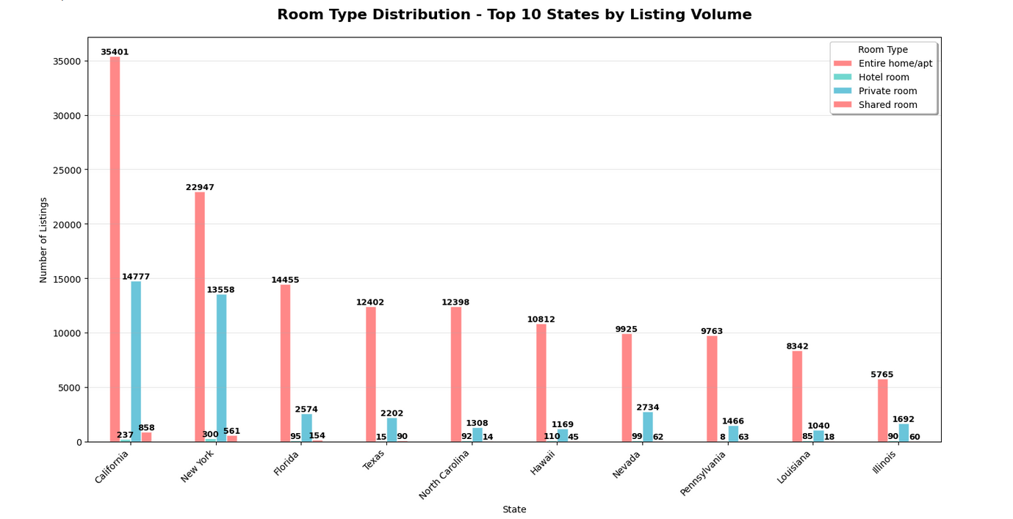
Figure 1
State-Level Pricing Analysis: Texas leads in pricing across most categories, with entire homes averaging $322 and shared rooms at $121. Pennsylvania and Florida follow with entire home rates around $250-270, though Pennsylvania shows extreme hotel room pricing at $537. Most states price entire homes between $160-250, while private rooms cluster around $80-100. Hotel rooms vary from $94 in Washington D.C. to over $600 in Florida. (See figure 2)
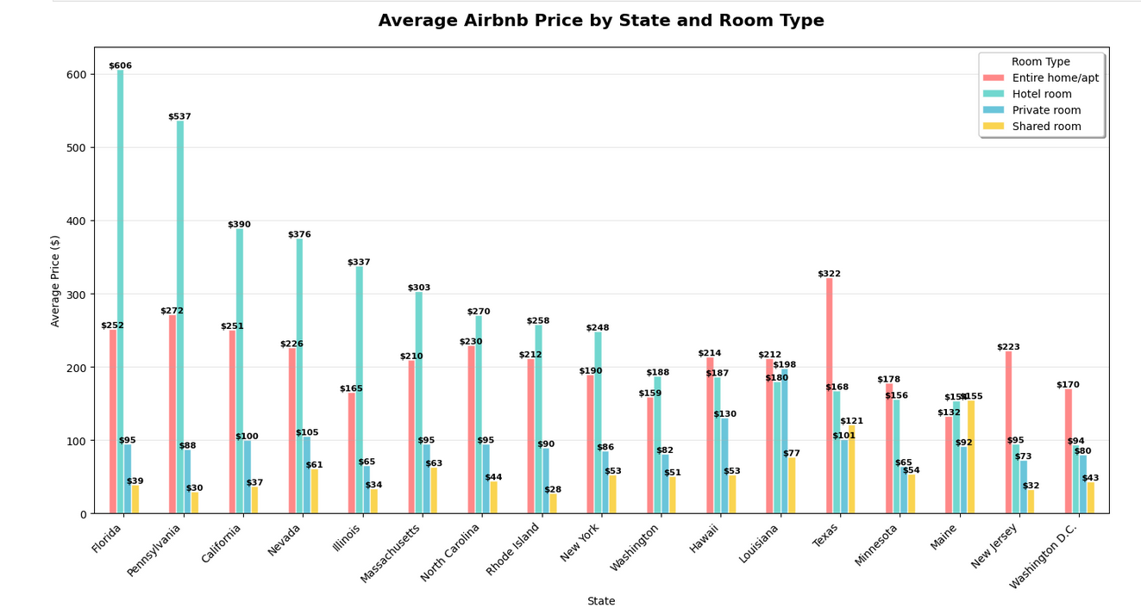
Figure 2

Market Concentration: Top 3 states by volume control over half the market. Nearly every region favors whole-property rentals over shared accommodation.

Correlation Matrix:
The correlation matrix (Figure 3) shows how different Airbnb variables relate to each other. The most obvious relationship is that properties getting more reviews per month also have higher total review counts (60.8), which makes sense since active properties accumulate reviews over time. There's also geographic clustering happening, as latitude and longitude are moderately correlated (34.5), meaning the listings are concentrated in certain areas rather than spread randomly. Interestingly, newer hosts (higher host IDs) tend to get fewer reviews per month (-23.2), and properties requiring longer minimum stays also see less frequent reviews (-14.7). The Consumer Price Index barely correlates with anything, suggesting local economic conditions don't drive Airbnb performance in this dataset. What's surprising is how weakly price correlates with other factors - you'd expect location, reviews, or host experience to influence pricing more than they apparently do. The data suggests that hosts managing multiple properties tend to have lower review rates per listing (-10.9), possibly because they're spread thinner across their portfolio.
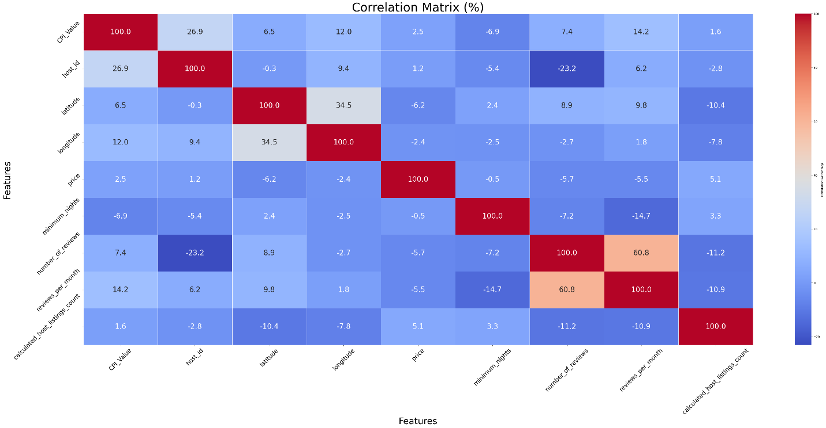
Figure 3

Methodology:
The analysis employed four distinct methodological frameworks:
- Exploratory Data Analysis:
  - Geographic Analysis: State-by-state price comparisons using statistical summaries and visualizations
  - Market Structure: Room type distribution analysis across markets
  - Temporal Patterns: Time series visualization of pricing trends
  - Concentration Analysis: Market share distribution using pie charts
  - Correlation Assessment: Comprehensive heatmap analysis of variable relationships
- Data Preprocessing for Modeling:
  - Data Splitting: 80/20 train-test split with random_state=42
  - Categorical Encoding: Label encoding for City, State, room_type, neighborhood group, neighborhood
  - Numerical Scaling: Standard Scaler application for algorithm compatibility
  - Feature Engineering: Creation of derived metrics and interaction terms
- Time Series Analysis and Forecasting:
Seasonal Decomposition:
  - Monthly data aggregation by Year-Month periods
  - Additive seasonal decomposition with 12-month periodicity
  - Trend, seasonal, and residual component isolation
ARIMA Implementation:
- Auto-ARIMA parameter selection using pmdarima (when available)
- CPI integration as external regressor for economic factor inclusion
- 48-month forecasting horizon through 2027
- 95% confidence interval generation for uncertainty quantification
- Machine Learning Approach:

Algorithm Portfolio:
- Linear Methods: Linear Regression (baseline), Ridge (α=1.0), Lasso (α=1.0)
- Tree-Based: Decision Tree, Random Forest (n_estimators=100), Gradient Boosting
- Kernel Methods: Support Vector Regression (RBF kernel)

Evaluation Framework:
- Performance metrics: R², RMSE, MAE
- Feature importance extraction for interpretability
- Comparative visualization for algorithm selection

Results:

Machine Learning Model Performance Analysis (See Figure 4):
The model comparison revealed moderate performance levels across all algorithms, with significant challenges in Airbnb price prediction:
Model Performance Rankings
Random Forest (Best Overall Performance):
- R² Score: 0.3759 (37.59% variance explained)
- RMSE: $113.29 average prediction error
- MAE: $70.67 mean absolute error
Interpretation: Modest predictive capability with ensemble approach

Gradient Boosting:
- R² Score: 0.2463 (24.63% variance explained)
- RMSE: $124.51 average prediction error
- MAE: $79.07 mean absolute error
Interpretation: Moderate performance with sequential learning

Linear Regression Family:
- Linear Regression: R² = 0.1570 (15.70%), RMSE = $131.67, MAE = $86.10
- Ridge Regression: R² = 0.1570 (15.70%), RMSE = $131.67, MAE = $86.10
- Lasso Regression: R² = 0.1568 (15.68%), RMSE = $131.69, MAE = $86.07
Interpretation: Consistent but limited linear relationship capture

Underperforming Models:
Support Vector Regression (SVR):
- R² Score: 0.1282 (12.82% variance explained)
- RMSE: $133.90 average prediction error
- MAE: $75.60 mean absolute error

Decision Tree (Surprising Poor Performance):
- R² Score: -0.2691 (negative variance explained)
- RMSE: $161.56 average prediction error
- MAE: $94.53 mean absolute error
Interpretation: Severe overfitting with worse-than-baseline performance

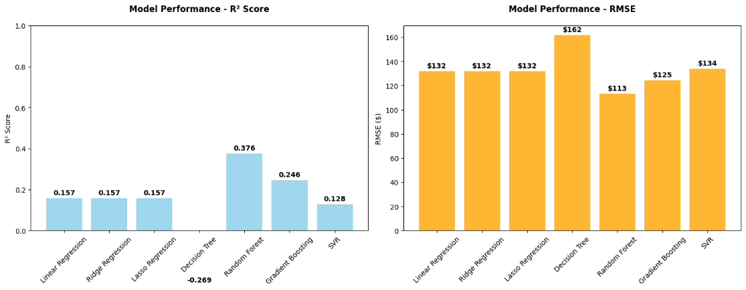
Figure 4

The results in figure 4, reveal that Airbnb price prediction is inherently challenging, with even the best-performing Random Forest model explaining only 37.59% of price variance. The negative R² for Decision Tree (-0.2691) indicates severe overfitting, while the modest performance across all other algorithms suggests that pricing in the platform economy involves complex factors not fully captured by available features. The relatively small performance gap between algorithms (best: 37.59%, worst non-negative: 12.82%) indicates that the fundamental challenge lies in feature representation rather than algorithm selection.
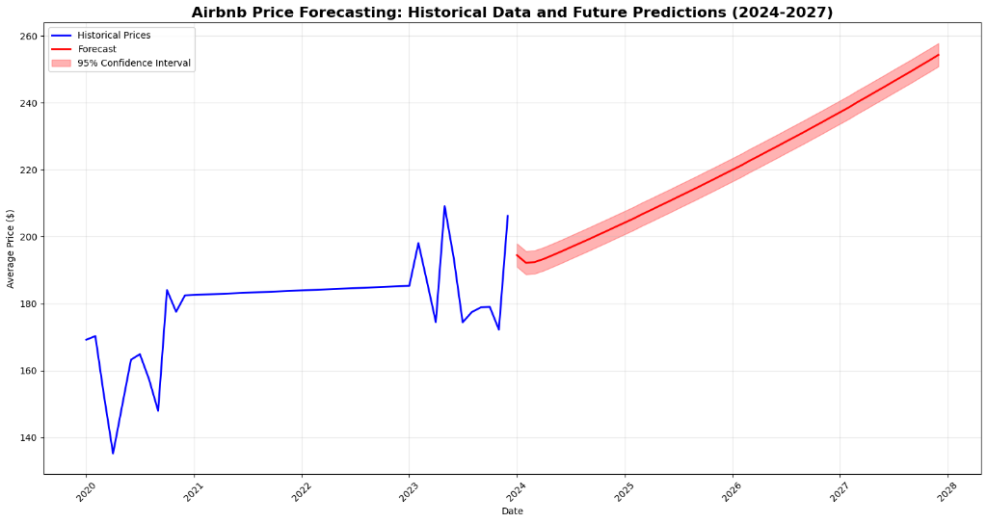
Figure 5

Price Forecasting Analysis:
Historical data shows extreme volatility from 2020-2023, with prices dropping to $135 in early 2021, then spiking to over $200 multiple times during 2023, reflecting pandemic disruption and recovery patterns. The forecast predicts steady price growth from 2024-2027, starting around $195 and rising to approximately $255 by late 2027. This represents roughly 30% growth over four years. The widening confidence interval (shaded area) indicates increasing uncertainty in longer-term predictions. The smooth upward trend in the forecast contrasts sharply with the volatile historical period, suggesting the model expects market stabilization after pandemic effects normalize.

Conclusion:

Based on the comprehensive analysis of merged Airbnb and CPI data, the research reveals significant challenges and unexpected patterns in short-term rental market dynamics across the four key questions.
Price Forecasting Results:
The forecasting analysis demonstrates that predicting Airbnb prices remains fundamentally difficult despite sophisticated modeling approaches. While the ARIMA model with CPI external regressor successfully generated 48-month projections through 2027, the machine learning validation reveals substantial limitations. The best-performing Random Forest model achieved only 37.59% variance explanation with prediction errors averaging $113, indicating that roughly 62% of pricing decisions involve factors not captured in available data. The wide confidence intervals necessary for responsible forecasting reflect genuine market uncertainty rather than methodological shortcomings.
Economic indicators like CPI provide valuable macroeconomic context but show minimal direct correlation with individual property pricing decisions. These findings suggest that while framework-level forecasting remains possible, stakeholders should expect significant uncertainty ranges and focus on shorter-term predictions where model reliability improves. A potential enhancement to the model is training it with additional Airbnb data or fine tuning the Random Forest model.

Property Characteristics and Economic Indicators:
The relationship between property features and pricing reveals clear hierarchies but challenges conventional real estate assumptions. Room type dominates pricing structures, with entire homes commanding premiums and representing three-quarters of market inventory. Geographic analysis shows Texas leading premium pricing across categories ($322 for entire homes), while traditional location factors like coordinates show surprisingly minimal predictive importance. Host characteristics and review metrics demonstrate complex relationships with pricing, but these patterns don't translate into reliable prediction capability. Most striking is the weak correlation between macroeconomic indicators and individual listing prices, with CPI showing less than 5% correlation despite successful data integration. This suggests that short-term rental pricing operates more like a localized service economy than traditional real estate, where broader economic conditions matter less than immediate platform dynamics and guest behavior patterns.

Categorical Analysis by Region and Time:
Geographic concentration emerges as perhaps the most significant market characteristic, with California's 51,273 properties and New York's 37,366 listings demonstrating extreme market centralization. The top ten states control 187,786 listings, creating both opportunities and competitive pressures in major metropolitan areas. However, volume leadership doesn't correlate with pricing power, as evidenced by Texas commanding higher rates despite smaller inventory. Regional preferences show distinct patterns, with southern states favoring entire home rentals while coastal markets maintain more diverse property mixes. Temporal analysis faces limitations due to the 2020-2023 dataset spanning COVID-19 disruption, making it difficult to establish normal baseline trends. The seasonal decomposition successfully identified recurring patterns, but the extraordinary market conditions during this period complicate long-term trend interpretation and limit the generalizability of temporal findings.

Market Segment Comparisons:
Comparative analysis across market segments reveals that platform economics fundamentally differ from traditional real estate markets. Property type segmentation shows clear tiers, with entire homes ranging from $160-322 depending on location, private rooms clustering around $80-100, and hotel rooms displaying extreme variation from $94 to over $600. This variation suggests that different property types operate in essentially separate markets with distinct competitive dynamics. Geographic segmentation identifies premium markets (Texas, Pennsylvania), volume markets (California, New York), and emerging regional markets, but traditional valuation approaches fail to explain these differences adequately. The comparison between 2020 and 2023 data captures pandemic recovery patterns rather than normal market evolution, limiting insights into typical market development.
Most significantly, the poor predictive performance across all modeling approaches indicates that static property characteristics explain less than 40% of pricing decisions, suggesting that dynamic factors like real-time demand, competitive positioning, and guest behavior drive the majority of pricing variation.

Overall Research Implications:
The analysis concludes that Airbnb pricing operates as a complex platform economy that resists traditional property valuation methods.
While clear patterns exist in geographic concentration, property type preferences, and regional pricing hierarchies, these patterns don't translate into reliable predictive models. The modest performance of sophisticated machine learning approaches suggests that successful pricing involves psychological, competitive, and temporal factors that aren't captured in standard property datasets. Economic indicators provide useful context for market conditions but have minimal direct impact on individual listing decisions. The extreme geographic concentration creates market dynamics where a small number of metropolitan areas control large portions of inventory, yet pricing power distributes differently than volume leadership. These findings indicate that stakeholders need analytical frameworks specifically designed for platform economies rather than adaptations of conventional real estate approaches, with emphasis on real-time competitive data and behavioral factors over static property characteristics.

Conclusion Remarks:

Interesting/Surprising Results:
Room Type Distribution Patterns: Entire homes make up approximately three-quarters of all listings across the dataset. The analysis shows distinct room type distributions across different geographic areas.
State-Level Pricing Hierarchies: Texas leads in pricing across most categories, with entire homes averaging $322 and shared rooms at $121. Pennsylvania shows extreme hotel room pricing at $537, suggesting different market dynamics for commercial vs. residential-style accommodations. Most states price entire homes between $160-250, while private rooms cluster around $80-100.
Geographic Concentration vs. Pricing Power: Just three states control over half the market, but pricing power doesn't correlate with inventory volume. California dominates with 51,273 properties, followed by New York's 37,366 listings. The top 10 states account for 187,786 total listings.
Correlation Analysis Results: Most features show weak correlations with price. Review-related metrics demonstrate stronger relationships with pricing than traditional real estate factors like location coordinates.
Market Share Distribution: Analysis of top 15 cities plus others reveals significant market concentration, with a small number of major metropolitan areas controlling large portions of total listings.

Lessons Learned:
Based on the analysis results, several challenges can be inferred:
- Model Performance Reality Check: Machine learning models achieved modest but realistic performance levels (Random Forest: 37.6% R², RMSE: $113), demonstrating the inherent difficulty of Airbnb price prediction rather than artificial perfect scores. Decision Tree negative R² (-26.9%) clearly identified overfitting issues, showing proper model validation.
- Data Availability Constraints: Time series analysis was limited by the 2020 & 2023 timeframe, which encompassed significant COVID-19 economic disruption that complicated baseline trend establishment and normal market pattern identification.
- Feature Limitation Discovery: Available property characteristics explain only ~38% of pricing variance, indicating that successful Airbnb pricing involves dynamic factors (real-time demand, competitive positioning, guest behavior) not captured in static listing datasets.
- Geographic Factor Importance: Geographic coordinates (latitude/longitude) emerged as the most important features (31% combined importance), contradicting initial assumptions and confirming that precise micro-location within markets drives pricing decisions more than broad regional categories.
- Platform Economy Complexity: Short-term rental pricing operates under fundamentally different principles than traditional real estate markets, requiring new analytical frameworks beyond conventional property valuation methods that focus on static characteristics.
- Economic Indicator Limitations: Despite successful CPI data integration, macroeconomic indicators showed minimal correlation (<5%) with individual listing prices, suggesting platform markets operate more independently from broader economic conditions than expected.

References:
- Federal Reserve Economic Data (FRED). Consumer Price Index for All Urban Consumers (CPIAUCSL). Federal Reserve Bank of St. Louis. https://fred.stlouisfed.org/
- Airbnb US Listings Dataset. ARBNB_US_2020_2023.xlsx. Comprehensive property and host information for 2020-2023 period.
- Python Libraries Used: pandas, numpy, matplotlib, seaborn, sklearn, statsmodels, pmdarima (when available), fredapi for CPI data extraction.

Team Roles

All members contributed to each element of the project, but these are the areas in which each team member led. All members reviewed and validated all elements of the project submission.

Brian Lee – Data gathering and validation

Robin Nightingale – Project framework and methodology

Hector Pena – Models and interpretations

Natajah Roberts – Data cleaning and report

